Given a list of numbers - List[Int] (1, 2, 3, 4, 5, 6, 7, 8, 9, 10)

- find the sum of all numbers

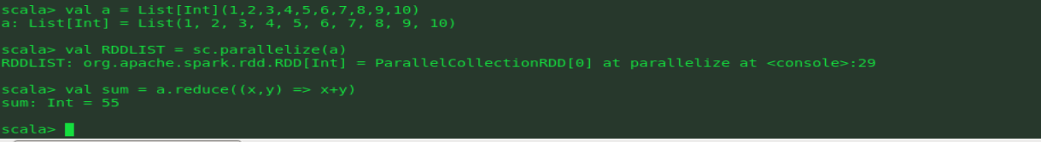

find the total elements in the list

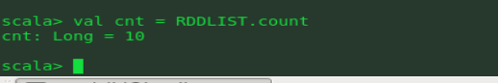

calculate the average of the numbers in the list



find the sum of all the even numbers in the list





find the total number of elements in the list divisible by both 5 and 3

